# Weighted Linear Regression Mathematical Derivation

The goal of the WeightedLinearRegressionCalculator class is to provide an object capable of finding a Least Squares Regression Line (LSRL) for a set of weighted points. This calculation is essential for processing an image of gaffer’s tape line on the floor. The algorithm we developed for finding this weighted LSRL makes use of a mathematical formula based on a standard solution in linear algebra for finding an LSRL, adapted to incorporate the relative importance of points when finding an LSRL.

The weighted LSRL will be the function:

$$\hat{y} :R →R$$

Such that the value of

$$\sqrt{\sum{k_{i}{\left(\hat{y}\left(x_{i}\right) - y_{i}\right)}^{2}}}$$

is minimized, where $k_{i}$ is the weight of the ith point, $x_{i}$ is the x coordinate of the ith point, and $y_{i}$ is the y coordinate of the ith point.

## Geometric Interpretation of Regression

Consider a collection of *n* points for which we wish to find a weighted LSRL. We can consider every function which is defined at the x-positions of those points. If we treat two such functions as equal if and only if they have the same values at each of those x-positions, then this collection of functions forms a vector space over $R^{n}$. Specifically, each of the *n* dimensions of the vector space represents the value of the function at one of those x-positions.

Now, we can define an inner product over this space. We do not need to assume that the basis we chose (with each dimension being the value of the function at a different x-position) is orthonormal, so we are free to define the inner product as $\overset{⃑}{a}∙\overset{⃑}{b} = {\overset{⃑}{a}}^{T}M\overset{⃑}{b}$ for any symmetric, positive-definite matrix *M* of our choosing. If we define it such that $M_{ii} = k_{i}$ along the diagonal, with zeros everywhere else, then the magnitude of a vector becomes:

$$\left|\overset{⃑}{v}\right| =\sqrt{\sum{k_{i}{v_{i}}^{2}}}$$

This is useful because it allows us to evaluate the “distance” of a potential regression function $\hat{y}$ from the function which exactly fits the data as:

$$\left|\hat{y} - y\right| =\sqrt{\sum{k_{i}{\left(\hat{y}\left(x_{i}\right) - y_{i}\right)}^{2}}}$$

Which is exactly the value we wish to minimize. Thus, we can optimize this value by finding the projection of the function which exactly fits the data onto the subspace of functions which are linear, as this will find the linear function which has the shortest “distance” from the data.

## Projection with an Arbitrary Metric Matrix

We shall start with the following diagram:

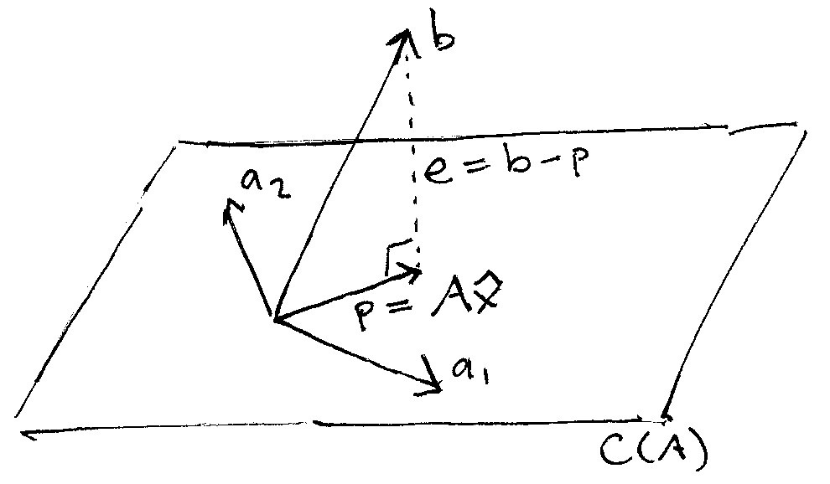

This illustrates the special case of projecting a vector in 3-dimensional space onto a 2-dimensional subspace, but it is sufficient for our purposes.

### Definitions:

$\overset{⃑}{b}$ is the vector which we wish to project onto a subspace.

A is the matrix whose column vectors are:

$$〈{\overset{⃑}{a}}_{1}, {\overset{⃑}{a}}_{2}, ⋯, {\overset{⃑}{a}}_{n}〉$$

which minimally span the subspace onto which we wish to project $\overset{⃑}{b}$.

$\overset{⃑}{p}$ is the projection of $\overset{⃑}{b}$

$\overset{⃑}{e} is the component of \overset{⃑}{b}$ that is orthogonal to the subspace

$\overset{⃑}{x}$ is the vector whose components are the scalars $x_{1}, x_{2}, ⋯, x_{n}$ such that $x_{1}{\overset{⃑}{a}}_{1}+ x_{2}{\overset{⃑}{a}}_{2}+ ⋯+x_{n}{\overset{⃑}{a}}_{n} = \overset{⃑}{p}$

### Derivation:

Since $\overset{⃑}{e}$ is orthogonal to this entire subspace, we know that

$$A∙\overset{⃑}{e} = \overset{⃑}{0}$$

Using the equalities labeled on the diagram, we can rewrite that as:

$$A∙(\overset{⃑}{b} - A\overset{⃑}{x}) = \overset{⃑}{0}$$

We then have:

$$A∙\overset{⃑}{b} - A∙A\overset{⃑}{x} = \overset{⃑}{0}$$

$$A∙\overset{⃑}{b} = A∙A\overset{⃑}{x}$$

$$\overset{⃑}{x} = {(A∙A)}^{-1}(A∙\overset{⃑}{b})$$

And finally, expanding our dot product, we have the final equation:

$$\overset{⃑}{x} = {(A^{T}MA)}^{-1}(A^{T}M\overset{⃑}{b})$$